Honeoye Valley Association
Meeting Minutes
6:30pm March 19, 2018
Held at the Honeoye Library
Board Members  Dan Lalonde President, Webmaster  Jerry Passer  Terry Gronwall  Dorothy Gronwall  Dave Baker Treasurer  Elaine Cook  Don Cook  Caroline Sauers Grapevine, Secretary  Tim Mc Auliffe  Len Wildman  Lindsay McMillan  Ken Klump | Present  Present  Present  Present  Present  Present  Present  Present  Absent  Present  Present  Absent | Guests
Approval of the Minutes
TG Motion to approve the minutes, JP second, Ayes unanimous.

Treasurer Report
Find Attached, Treasurer Report from Dave Baker.
DL motioned to accept the treasurers report JP second, Ayes unanimous.

Wild Apricot Review
DL gave an update on wild apricot, and feels it is still a valuable product.

Roadside clean up
Jerry will take care of the A frame signs. Bill Woods will take care of the road assignments. The suggestion was to ask Sure Fine for the bags, Bill will follow up. Dave Baker will create a flyer and social media advertising. Handing out flyers Jerry Passer 8 to 10. The Gronwall’s 10 to noon.
Try to find a good Map of the Town. Send digital sign to Dave Baker. Dave Baker is also going to follow up on a map.
The Gronwall’s will on April 14th hand out flyers, 300 8 am to noon.
Breakfast at the church, 7 am to 9. Bill Will Confirm times.
Contact the trash people and Tom Fleig. Ask Tom how it works….
County Jail with helpers,

Field Camp Scholarship
DB asked if the board would like to continue to support a student the cost is $749 a full 3 credit class. We would like to have the scholar submit an essay for the Grape vine. TG motion to support one student with a Field Camp Scholarship, Len second, Ayes unanimous.

Photo contest
LM to make the drop box, flyer and social media. HVAphotos@gmail.com (change of email address)
Instructions to participants - Directly email images with title & mailing address, The members and public in attendance will vote at the annual meeting. Some discussion of inviting Tim Williams to attend the annual meeting and get students involved. Photos should be coming in that were captured in the Honeoye Lake Valley Watershed and Wetlands surrounding Honoye Lake. This is an amateur photo contest. The board suggested three Prizes What is the date? CS donated to HVA Members photos 10 T- shirts,

Water Craft Steward Program
Internal communication error, 2018 Honeoye Lake will take part in the master grant Mon. Tues. Wed. Mini grant Park and rec Thursday, Friday Saturday Sunday.
We could use the mini grant for pamphlet invasive plants -or- Lake Stewart for May and Sept. $6,000. Discussion as to fund the lake Stewards or educational funds. Discussion to lake Stewart coverage weekends in May all of Sept. and do weekends until mid-October. Terry Gronwall to ask. Motion to request the grant JP, with DC second Ayes unanimous.

Neighborhood Outreach Group
Honeoye Lake Park Association DL, TG and DG met with them. Update them for the H2o Task Force and the HVA. The point is to open communication lines and network with them. Discussion to asking their membership to join the HVA. Talk about a free membership to the HLPA. Next meeting the North Lake Shore, South Forest View, and others, as in the Francis track. Ask any of our Members I they are also members of lake associations.

Citizen Science CSLAP Program
How do we get others to volunteer to take water samples?

Several ideas, to get started could we as in most of the other lakes use shore line volunteers. Cndga, Owasco, Seneca. Reach out and involve more of the lake resident’s sections of the lake shore areas. Suspicious HAB’s report picture street address or GPS coordinates. More people looking more blooms we will find. ON the other hand, we may involve people all around the lake. We would need to train them as to what blooms look like.
Second suggestion, citizen science secchi disk program, water clarity, 18 sites random, once a week. They have a program coordinator that puts it in a spread sheet. Ideally a minimum of north south east west shore alignment. We should add water temperature. $100 person to train. Coordinator can send all of it together.
Third suggestion is we have one open water site, and near shore sites, close to several board members homes, can board members check the shore line on Thursdays, take a photo with smart phone and give an update of the water quality.
Lake organizations to take a secchi disk and do some monitoring. One-time cost. We can start with secchi disk volunteers, we will find the ones that have a natural interest and add more to some of the folks later. Specific Proposal at the next board meeting. Water Resource Council in November could pay for it.

Governor HAB’s meeting –
Every week that goes by less sure of the outcome, reduce expectations with the public. DEC has outsourced the HAB action plans to a consultant. Concerning that the plans will be cookie cutter at a high level.

Next Meeting April 16, 2018 6:30 – 8PM Location Richmond Library

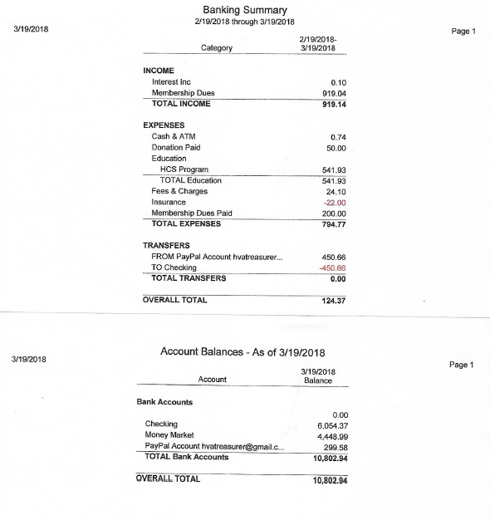

Tabled for future meeting, Board Members Please Consider Championing something on the list you are interested in.

Review of HVA Mission and projects review – All Time left
-projects – duck race, canoe race
- town effort to protect beach area with boom or some device(s)
- Increase emphasis on HAB mitigation, elimination, minimization, etc – algaecides? Tie in with TMDL results and potential solutions
- Major Stream vernal pools or solution to slow water.
- Fund study to update macrophyte study? Address harvester and possible herbicides
2nd pass at planning meeting ( Use regular meeting time) – ALL
- Ranked items from each board member

* Committees
- membership
- letter writing
-personal reach out
- revised emails
- automatic renewals
- lake associations
- community projects
Yard Waste
Food Drive
Boat Launch monitor
Co Sponsor Pirate Festival
Start a parade of Boats event with prizes
Develop a lake safety/good lake user brochure to hand out to boat renters and boat launch visitors
New sign about lake rules at Trident Marina
Sandy Bottom Nature Display/Sigange/garden
- communications
- symposium
- newsletter, email blasts
- newspapers
- website refresh
- Grapevine
- Educational Outreach
- Lake Living Guide
- School program
- Boat safety, lake use guidelines , handouts at Marine, boat launch
-How to renew emphasis on Macrophyte Study and publishing results
- New sign about lake rules at Trident Marina
* Charitable contributions to community efforts
FLCC scholarship
Town beach bubblers?

Communications
• -Grapevine – Caroline Shore line plantings
• -Facebook Page - Carole

Lake Quality/HLWTF
- Richmond Honeoye Lake Maintenance Committee - NEW???

